

**Department of Gender and Community Based Services**

**GRIEVANCE REDRESS POLICY**



**Signed by**

**Yiga Benon**

**Town Clerk**

**Introduction**

The Ministry of Gender, Labour and Social Development (MoGLSD) is mandated under Chapter 4 Articles 31 – 40 and Chapter 16 Article 246 of the Constitution of the Republic of Uganda to protect and promote the rights of vulnerable population, to address gender inequalities, to ensure cultural growth, labour and employment as well as community mobilization and empowerment.

The Ministry of Gender, Labour and Social Development is the lead agency in the management of Social, Safety and Healthy Safeguards. which are delivered through mobilization, empowerment and protection of communities.

These safeguards are delivered to Mobilize and empower communities to harness their potential while protecting the rights of vulnerable groups.

Kira Municipal Council like any other Local Governments in the Country, has the Department of Gender and Community Based Services which is mandated to carry on almost same roles as for its line Ministry above at the Local Government Level. It’sfocus is mainly; community mobilisation, empowerment and protection of the vulnerable, marginalised and special interest groups who are often side-lined and excluded from participation in and benefits from economic growth.

The department/sector promotes issues of labour productivity and employment, social protection, gender equality, equity, human rights, culture and empowerment. It aims to achieve a better standard of living of community members.

There are a number of both public and private sector programs and projects that are funded within Kira MC and other Local Governments. In view of this, several grievances resulting from the implementation of these projects and programs have been documented for instance: delayed payment of workers by contractors; none payment of suppliers, inadequate or no provision of free Personal Protective Equipment to workers by the contractor; unfair dismissals, dust pollution, land disputes among others.

The above have necessitated formation of different Grievance Redress Committees and a systemised Grievance Redress Framework to address several grievances.

Below is a guide on the composition and operationalisation of Grievance Redress Committees (GRCs).

**Purpose**

To provide minimum standards and procedures for Government, Non-Government and Private Sector actors to prevent, mitigate and respond to social, safety and health safeguards (Grievances)

The emphasis is on:

* Social protection;
* Equality and equity;
* human rights;
* Culture;
* Suitable Working Conditions;
* Employment; and
* Vulnerable Groups (Women, Children, Unemployed Youth, Internally Displaced Persons, Elderly, Persons with Disability

**What is a Grievance?**

A Grievance is a concern or complaint raised by an individual or a group within communities affected by project activities. It requires an intervention**.**

**Types of Grievances**

1. Formal Grievance: A complaint submitted through official channels
2. Informal Grievance: A complaint raised without formal procedure
3. Individual Grievance: a complaint made by one individual
4. Collective Grievance: A complaint made by a group of people.
5. Workplace Grievance: Complaints related to employment conditions**.**

**Causes of Grievance/complaints (project specific**

1. Restricted access to services or facilities due to project works
2. Blocking of right of way
3. Contamination of water sources
4. Misconduct by contractor’s workers
5. Poor waste management practices
6. Nonpayment of workers, etc

**Grievance Management**

* *A set of specified procedures (*institutions, instruments, methods and process)through which grievance resolution is sought and provided.
* It involves receiving, documenting and referring of complaints from individuals, groups, communities affected by *project activity / ies*.
* GRM involves formation of Grievance Redress Committees (GRC) at different levels for example:Community, Project, Sub-County / Division; andDistrict/Municipality/City).

**Principles of Grievance Management**

1. Accessibility
2. Fairness
3. Transparency
4. Capability
5. Confidentiality
6. Objectivity and independence
7. Timeliness
8. Keeping accurate records
9. Gender responsiveness and social inclusion

**Purpose of Grievance Management**

To handle complaints from Project Affected Persons (PAPs) / community members / workers within the project affected areas using well-documented systems to ensure that their complaints are effectively and efficiently addressed

**Grievance Redress Committee**

The Grievance Redress Committee is a body that receives and processes complaints from citizen’s/communities affected by project activities and takes action.

**Roles of Grievance Redress Committee**

(i) Receive, document, address and /or refer complaints/issues in relation to the Programme.

(ii) Acknowledge receipt of the complaint;

(iii) Hold meetings whenever cases arise;

(iv) Sensitise communities about the existence of the GRC and its operations i.e. how, where and who to report to. The contact/s of person/s to report to must be shared with the community/ stakeholders; and

(v) Awareness creation about the project

**Channels for Reporting Grievances**

* telephone calls, text messages, face to face, letters, WhatsApp messages, web site reporting, barazas etc.

**Composition of Members of the Grievance Redress Committees at the different levels.**

**Project Level**

|  |  |  |  |  |
| --- | --- | --- | --- | --- |
| **Level** | | **Chair** | **Secretary** | **Composition of Members 9** |
| **Project** | **CDO of the hosting LLG** | | **To be selected by the Chairperson from among the GRC members drawn from the Community** | * **Chairperson;** * **Secretary;** * **-3 Community Members chosen from (Women, Persons with Disability (PWD), youth, Opinion leader, cultural institution, community Organization representatives);** * **-2 representatives of Workers (Female and Male); and** * **-2 representatives of Management (Female and Male).** |

**LLG Level/Division**

|  |  |  |  |
| --- | --- | --- | --- |
| **Level** | **Chair** | **Secretary** | **Composition of Members 9** |
| **Subcounty / Division** | **Senior Assistant Secretary**  **(SAS)**  **Assistant Town Clerk (A/TC)**  **Or a nominee (technical person) by the SAS, ATC** | **Community Development Officer (CDO)** | * **Chairperson;** * **Secretary;** * **Three (3) Community Members from existing structures e.g., Parent Teachers Association (PTA), Health Unit Management Committee (HUMC), Board of Governors (BOGs),** * **One (1) Representative of vulnerable groups (e.g., Women; Youth, PWDs, Older person)** * **One (1) Technical Person in the subject matter of the project;** * **One (1) Representative of Non-Government Actors i.e., Civil Society Organizations (CSOs) or Faith Based Organizations (FBOs)or Community Based Organizations (CBOs); and** * **One (1) Project Affected Person (PAP).** |

**Higher LG/Municipality**

|  |  |  |  |
| --- | --- | --- | --- |
| **Level** | **Chair** | **Secretary** | **Composition of Members 9** |
| **District / Municipality**  **/ City** | **Town Clerk**  **Or a nominee (technical person) by the TC** | **Community Development Officer (PCDO)** | * **Chairperson;** * **Secretary;** * **Three (3) Community Members from existing structures e.g., PTAs, HUMC,** * **One (1) Representative of vulnerable groups (e.g., women; youth, PWDs, Older person)** * **One (1) Technical Person in the subject matter of the project;** * **One (1) Representative of CSOs or FBOs or CBOs; and** * **One (1) Labour Officer.** |

**Roles of GRC**

1. Sensitise communities about the existence of the Committee and its operations.
2. Guide communities on how, where and who to report to.
3. Communicate mediums for reporting such as *Suggestion Boxes, telephone calls, text messages, emails, face to face, letters.*
4. Receive and document complaints/issues.
5. Hold meetings whenever cases arise.
6. Resolve cases within three (3) weeks of receipt of each complaint.
7. Refer Cases that cannot be resolved at a particular level to higher level.

Note: ***There shall be a complaints log that shall be kept and managed by the GRC Secretary***

**Expected deliverables from GRC**

1. Schedules of planned meetings;
2. Monthly reports of grievances handled;
3. Quarterly reports of grievances handled; and
4. Minutes of meetings held, both adhoc and planned
5. Identification of Grievances

**Scope of Grievances**

The GRC will handle only cases related to the project.

GRC will register all cases they receive **BUT WILL NOTHANDLE** capital nature such as murder, rape, defilement, aggravated robbery. If such cases are reported to the GRC, they shall be referred to the Police.

**Case Referral Path**

Cases that cannot be resolved at that particular GRC level will be referred to the next level e.g. if a case is not resolved at project level, it will be referred to the Chairperson at LLG level while those that have not been resolved at LLG level, will be referred to the Chairperson of the HLG level.

If the mater cannot be resolved at LG level it should be forwarded to the Permanent Secretary, Ministry of Gender, Labour and Social Development.

**Important Notes about the GRC**

1. The quorum of a GRC at all levels will be ***five (5)*** members.
2. If a member/s is an alleged perpetrator of the complaint, he /she will not attend the meeting/s as GRC member.
3. The GRC at all levels will operate within the laws of Uganda.
4. If a GRC already exists at any level , its structure should be reviewed in line with the Social, Safety and Health Safeguards Implementation Guidelines for Local Governments.
5. *The GRC Chairperson can co-opt a knowledgeable person when a particular case is being heard /settled.*
6. *GRCs will be inaugurated by Political Leaders at the various levels.*
7. *A member is free to tender a resignation at any time and will be replaced by another member from the group they represent.*
8. *There shall be deliberate effort by the Municipality to train all GRC members on their roles and responsibility.*

**Challenges in Grievance Management**

1. Fatigue of committee formation at the Local Governments
2. Staff turnover and failure to handover documents on GRM to predecessors
3. Absence of clearly defined channel to route grievances to central government
4. Absence of GRC at Municipality.
5. Inadequate logistical support to GRCs e.g. grievance logs, stationary
6. Inadequate training to GRCs

**Constitution of GRC**

1. The GRC should be constituted before the project commences/site is handed over to the Contractor.
2. Clarity on how to manage grievances for completed projects should always be emphasized.
3. Confusion betweenaggrievance, complaint and dispute (Labour Disputes, Attribution and Settlement) Act 2006 sometimes arises.
4. Confusion between the mandate of GRC and the Consultative Committee under Public Service which is a statutory and is part of the Public Service (Negotiating, Consultative and Disputes Settlement Machinery Act 2008) which addresses issues of public servants.
5. There should always be evidence that Principles of GM (Accessibility, Fairness, Transparency, Capability, Confidentiality, Objectivity and independence, Timeliness Keeping accurate records&Gender responsiveness and social inclusion) are followed.
6. A proper procedure of addressing complaints should be known to the stakeholders.
7. Receiving, documentation, processing complaints, referral and reporting on grievances should be clear.

**Importance of Addressing Grievances Promptly**

* Maintains Trust and Morale it shows that the organization values its members' concerns, fostering trust between employees and management/prevent frustration and demotivation, maintaining a positive workplace atmosphere.
* Prevents Escalations
* Enhances Productivity
* Legal Compliance and Risk Management
* Improves Organizational Culture (Open Communication/Respect and Fairness)
* Employee Retention (Reduced Turnover/Loyalty)
* Feedback for Improvement (Organizational Learning-improve policies, procedures, and practices)
* In summary, addressing grievances promptly is essential for maintaining a healthy, productive, and legally compliant workplace. It fosters trust, prevents escalation, enhances productivity, and contributes to a positive organizational culture and reputation.

**Techniques for de-escalating conflicts and finding mutually acceptable solutions**

* *De-escalating conflicts and finding mutually acceptable solutions requires a combination of communication skills, empathy, and strategic approaches.*
* Active Listening:
* Give Full Attention: Listen to the other person without interrupting.
* Acknowledge Feelings: Show empathy by acknowledging their emotions.
* Paraphrase and Reflect: Repeat back what you heard to ensure understanding the issues at hand.
* Use Neutral Language
* Avoid Blame: Use "I" statements instead of "you" statements to avoid sounding accusatory.
* Be Objective: Focus on the issue, not the person.
* Set Boundaries
* Define Limits: Clearly state what behavior is acceptable and what is not(Guiding Principles).
* Stay Firm but Fair: Be assertive without being aggressive.
* Use Mediators if Necessary
* Third-Party Help: Involve a neutral third party to facilitate the discussion.
* Mediation Techniques: Use structured mediation techniques to guide the conversation.
* Develop a Plan of Action
* Set Clear Steps: Agree on specific actions each party will take to resolve the conflict.
* Monitor Progress: Follow up to ensure the agreed-upon actions are being implemented.
* Reflect and Learn
* Review the Process: After resolving the conflict, reflect on what worked well and what didn’t. be realistic to yourself and make self-evaluation.
* Apply Lessons Learned: Use insights gained to improve future conflict resolution /management and improve strategies.
* By applying these techniques, you can effectively de-escalate conflicts and work towards mutually acceptable solutions. The key is to remain calm, empathetic, and focused on collaboration throughout the process.

Annex 1: **Grievance Acknowledge Receipt (GAR)**

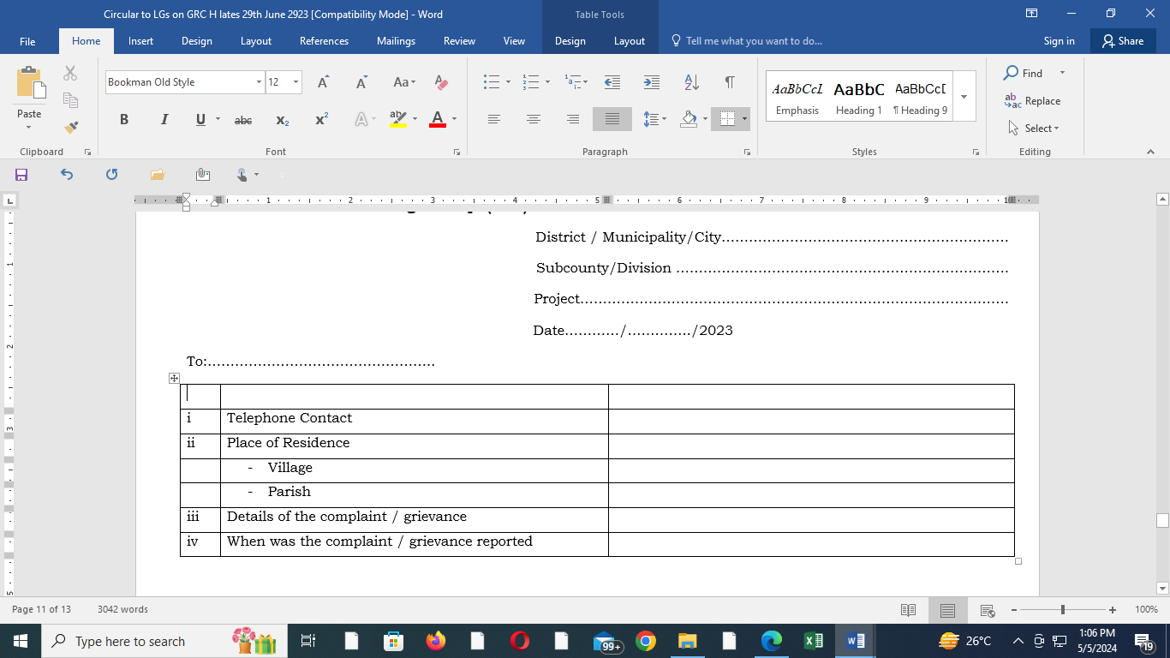

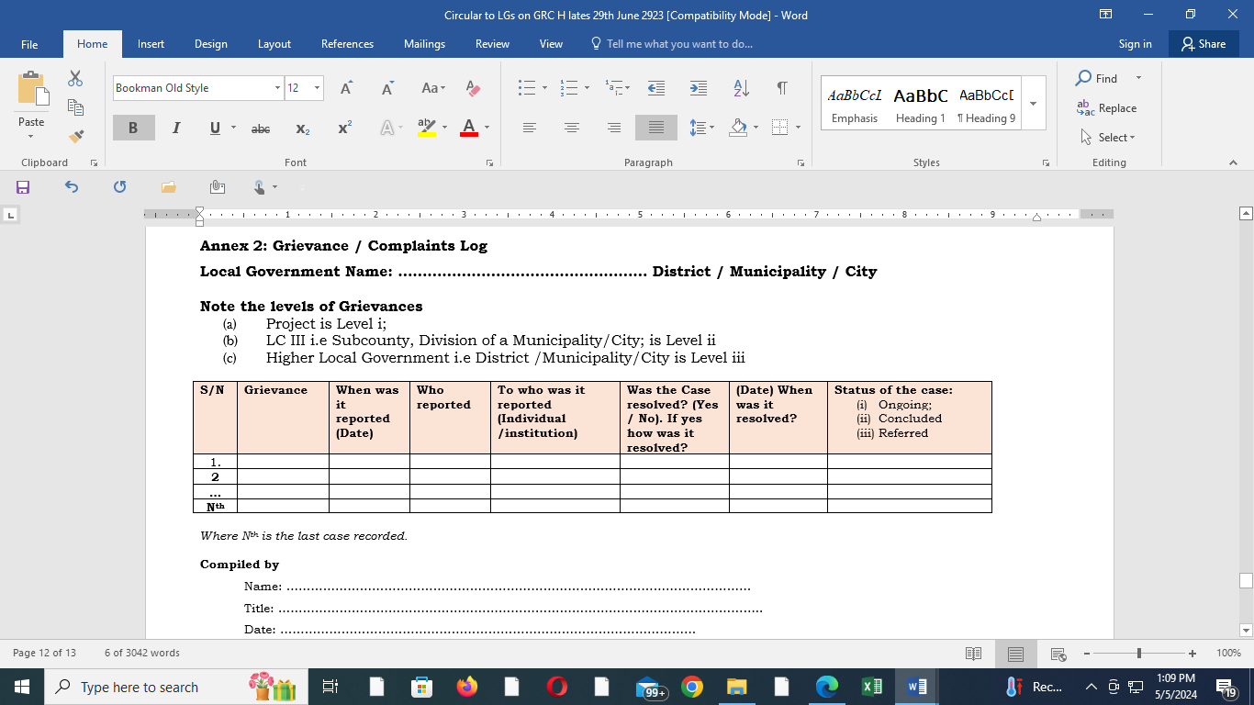

Annex 3: Compositions/Names of GRC members of different projects

|  |  |  |  |  |
| --- | --- | --- | --- | --- |
|  |  |  |  |  |